**Unit-2 -Managing Products**

**2. Magento - Product Overview**

Products are the items or things that are sold in Magento. Product can be anything that is capable of satisfying the customer’s needs. This includes both physical products and services.

**Product Types:** Magento provides 6 different types of products. Appropriate selection of product type is essential for accessing the appropriate set of features required to sell the product. Following are the product types available in Magento.

* **Simple Products**
* **Grouped Products**
* **Configurable Products**
* **Virtual Products**
* **Bundled Products**
* **Downloadable Products**

**Simple Products**

These are general product type, which are the most used products. In this section, there are no options for selecting size or color of the product. **Example**: Coffee cup, DVD's, Camera lens, etc.

**Grouped Products**

This is a group of simple products. In this type, you cannot specify a specific price for a product; you can just specify the discount. **Example**: Cell phone + Memory card + Earphone

**Configurable Products**

In this type, customers can select products according to their color and size before purchasing. **Example**: Cell phones obtained in different colors and sizes.

**Virtual Products**

Virtual products are those which do not have physical counterpart, i.e. these are used for virtual items. These products cannot be shipped or stocked. **Example**: Online training course.

**Bundled Products**

Bundled products are those products, which cannot be sold separately and doesn't give any choice to the end user. **Example:** Consider you want to buy a cell phone which includes earphone, memory card, battery, charging cable, etc. These are together called bundled products. These products cannot be sold individually but can be sold within the bundle product.

**Downloadable Products:** Products which are available for download are known as downloadable products. Example: MP3 file, ebook, documents, etc.

**Product Attributes**

Attribute describes the property of the product. Product attributes helps to set product properties such as color, size width, height, etc. and makes the product unique. You can add as many attributes to your product as required.

**2.1. Catalogue Creation**

It is rather inconvenient to manually add a large number of products at once to a Magento installation. Inserting products one by one will take a long time especially when you have hundreds or thousands of products. In such cases you need an automatic way to add all those products to your Magento online store. We will address all steps you need to take in order to achieve a successful import.

First, access your Magento administrator backend and go to **Catalog -> Categories**.

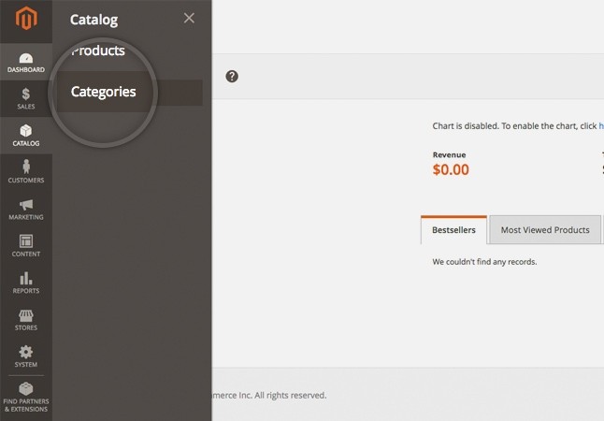

Create all product categories you will need. You can do so by filling the form displayed below:

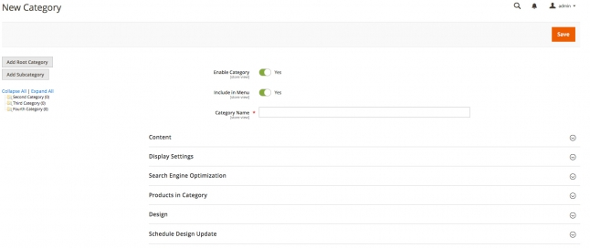

When you fill the form with all the information you like click the **Save Category** button.

Bear in mind that at this point you should make note of the newly created category IDs. It would be best to save them in a simple text file as you will need them for the import. The category ID will be displayed upon saving the category.

If you plan to have additional attributes for the products you are importing you will need to create those via **Stores** menu > **Product** under the **Attributes** section. You can use this functionality to add all custom attributes that are not present by default in a standard Magento installation. Note also that you can add additional attributes later at the moment you are creating a sample product. It is up to you whether to create the attributes before that or at the point you are creating the first product.

The next step is to manually add a product to your Magento installation. You will later export this product and use it as a template for importing the large batch. Make sure you include all attributes you will use for the products you are going to import in the sample product.

Once you create the new product and save it it will appear in the products list for your Magento store.

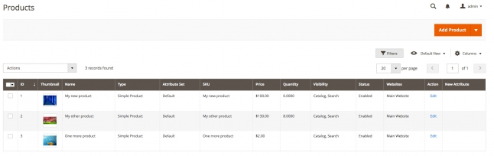

You are now ready to make the sample export that you will use as a template. In the Magento administrator area go to **System** menu **> Data transfer** section **> Export.** This would redirect you to a new page where you should select **Products** from **Entity Type** Dropdown and **CSV** from **Export File Format.**

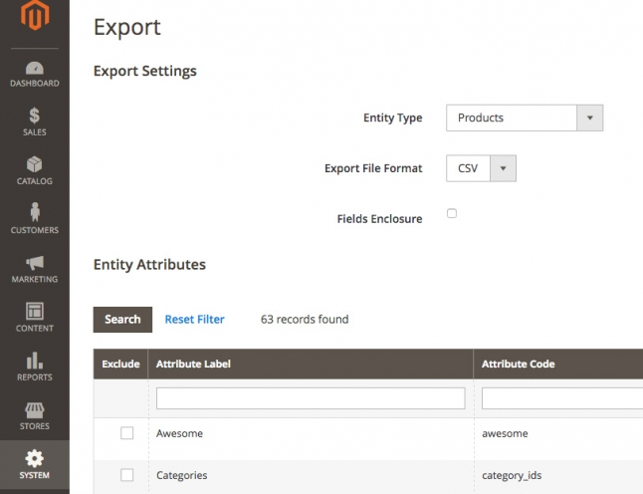

Now you should exclude the unnecessary attributes from the list by selecting them and then click on **Continue** from the bottom of the page.This will save a new file on your computer with a name similar to catalog_product_YYYYMMDD_randomnumber.csv .The file will include columns for each of the attributes you have defined for your products. Open it in a spreadsheet program (MS Excel, Open Office Spreadsheet) and add the products you would like to import. Make sure you are copy/pasting the corresponding attributes in the correct columns. Also here is when you will have to add the category IDs. Use the IDs from the text file you saved earlier and put the corresponding category ID for the products you are adding.

Once you have accomplished the above go back to the Magento administrator area and go to **System** menu **> Data transfer** section **> Import.** Now select **Products** from the **Entity Type** dropdown. After that select **Products** from Entity Dropdown, and **Add/Update** from **Import Behaviour** dropdown. Now upload the CSV file by clicking on the **Browse** button next to **Select File to Import.**  If you have added images, you should also specify the path on the server where you uploaded them. Add the corresponding path to the **Images File Directory** section.

When ready click on the **Check data** button. If there are no issues or error with the import, a*File is vaild!* message and **Import** button would appear.

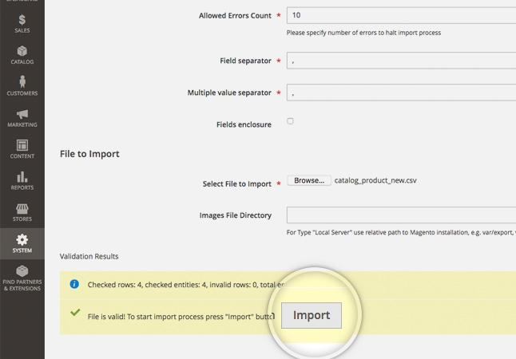

To initiate the process click on the **Import** button. When the import completes you will get the *Import successfully done* message.

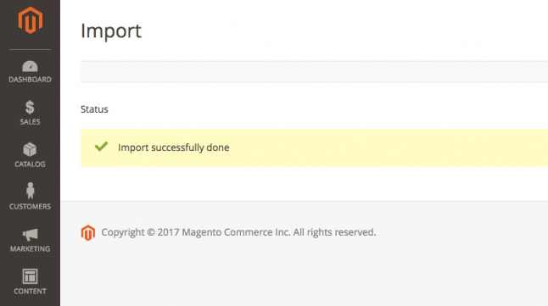

**2.2 Category Management**

This section covers the following topics:

* How to create a category in Magento
* How to add a category image in Magento
* How to list all available categories in Magento

Magento categories are a useful way to sort and organize your product. In this section, we will show you how to create and manage categories in your Magento store.

**How to create a category in Magento**

In order to create a new category for your products, go to your Magento admin area > **Catalog** > **Categories.** On the left you will see the available categories (if any) and above them you will see two options - **Add Root Category** and **Add Subcategory.**

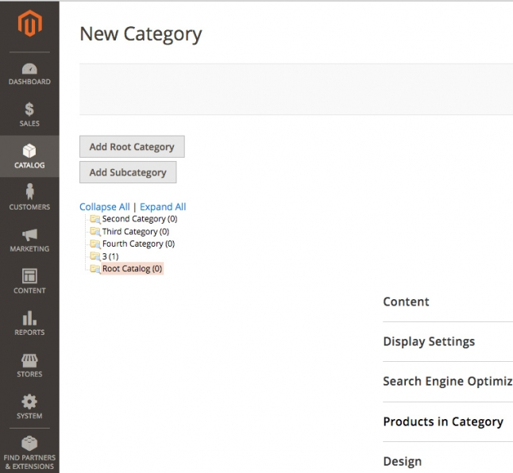

For the purpose of this section we would create a new subcategory by clicking on the **Add subcategory** button. You should fill in its **Name**, and toggle the **Enable Category**and **Include in Menu** buttons to **Yes** to include it in the navigation menu. These are the General Information settings for the category.

From the other tabs available you can also manage:

* **Content -** here you may add category image, description, Add CMS Block;
* **Display Settings** - here you can set category Display Mode, whether it is Anchor (i.e. whether or not it should inherit the products in its subcategories) and the product listing sorting options;
* **Search Engine Optimization** - in this tab you may choose URL key, which, if set, will be used in the links to this category. This is useful for SEO purposes - when sites are indexed, it is considered a plus to have as many relative keywords as possible in the URL. If the category is called "PC", you may want to set this field to "personal-computers" to include two additional keywords in the link.
* **Category Products** - this tab allows you to add existing products to the category
* **Custom Design** - from this tab you can select the design for this category, as well as its layout;
* **Schedule Design Update** - this tab allows you to schedule the update for a certain time.

**How to add a category image in Magento**

Adding a Magento category image is simple. From the Magento admin area > **Catalog** > **Categories** select the category which you want to add an image to. Then click the **Content** tab and click on the **Upload** button next to the **Category Image** field.

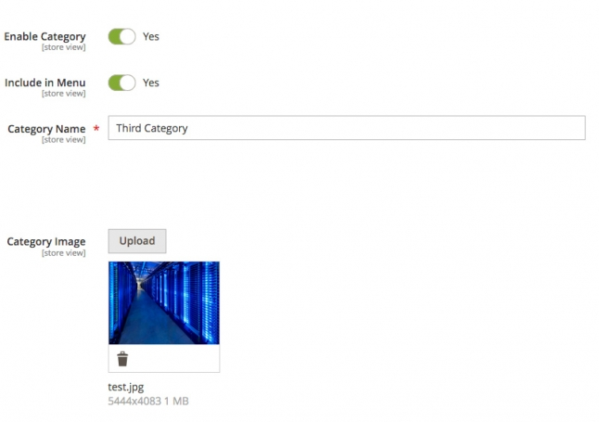

Locate the image you want to set for this category on your computer. The image will appear in the **Category Image** field and you should click **Save** to apply the changes.

**How to list all available categories in Magento**

If you want to get a list of all available Magento categories, go to your Magento admin area > **Catalog** > **Categories**. From the **Categories** menu on the left click **Expand All** and your whole category tree will be displayed.

**2.3 Product Adding**

This section covers the following topics:

* Add Products in Magento
* Add Media to Your Products
* Manage Product Attributes

One of the most important parts of managing an e-commerce application is the products. In Magento this process consists of a few main parts.

**Add Products in Magento**

To add a new product in your Magento website you should go to the Magento admin panel > **Catalog > Products.** Afterwards click on the **Add product** button at the top right of the page.

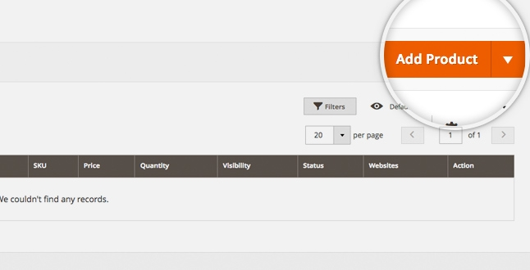

This would redirect you to the next page where you should input the product's options like *Attribute set*, *Product name*, *SKU, price*, etc. There is also option to add *Images*, *Videos*, setup *URL key* and much more. You may review all of the available options when you scroll down. You may also add a new attribute if necessary by clicking on the **Add attribute** button.

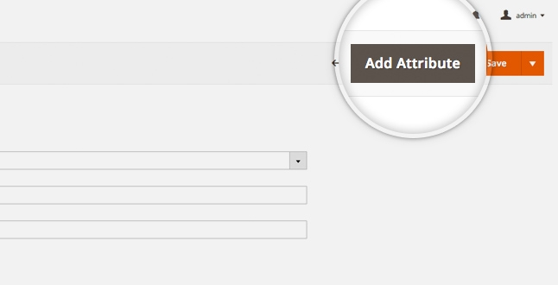

This would open a pop-up window which you may use to add the desired Attribute. When ready, click on the **Save attribute** button.

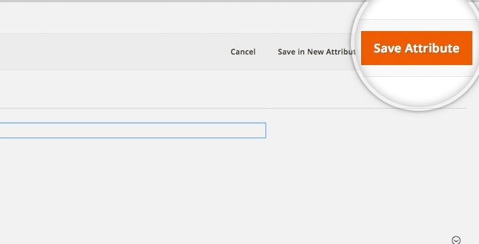

When you fill in the necessary details for your product - just click on the **Save** button

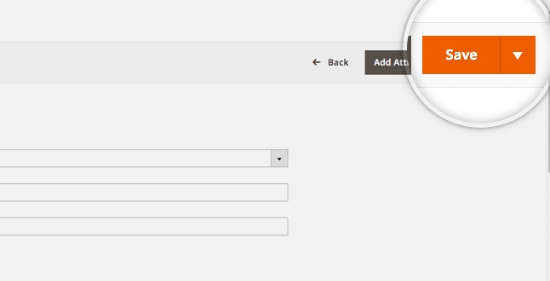

**Add Media to Your Products**

Adding an image to an existing product is easy in Magento. What you need to do is go to the **Catalog > Products** page and select the product you want to add image for or click on the **Edit** link in the **Action** menu.

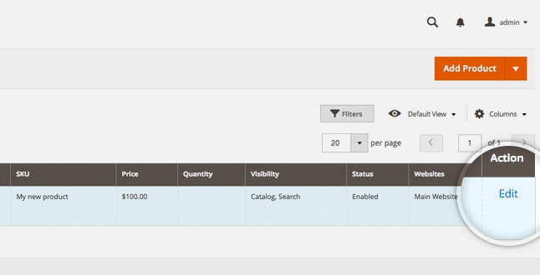

You will be automatically redirected to edit the product where you should scroll down to the Images and Videos section. To browse for an Image click on the **Browse to find or drag image here** icon. As the name of the icon suggests, Magento 2 provides the option to drag an image to upload it.

A **stock keeping unit (SKU)** is a product and service identification code for a store or product, often portrayed as a machine-readable bar code that helps track the item for inventory. A stock keeping unit (SKU) does not need to be assigned to physical products in inventory.

A **Universal Product Code(UPC),** a unique 12-digit number assigned to retail merchandise that identifies both the product and the vendor that sells the product. The UPC on a product typically appears adjacent to its bar code, the machine-readable representation of the UPC.

|  |
| --- |
| Image result for sku code means |

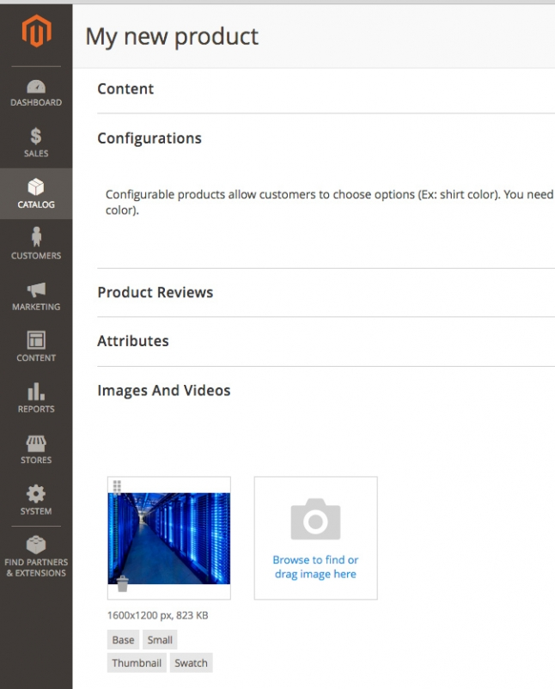

To add a video, just click on the **Add Video**button and a pop-up window would appear.

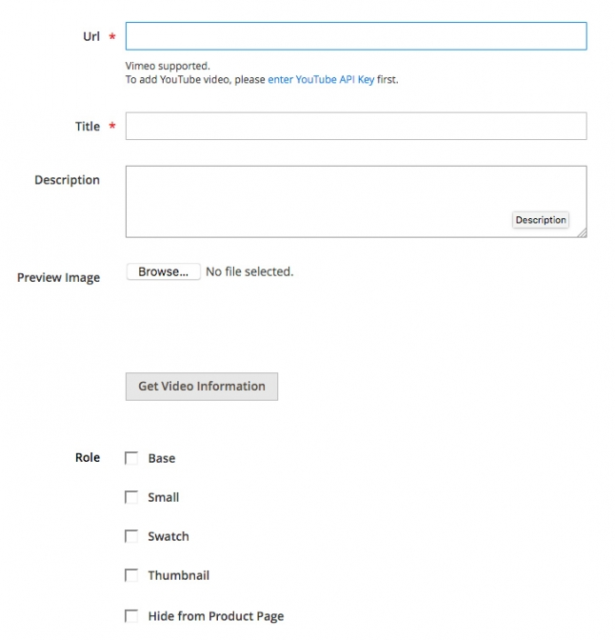

Here you may browse for video or fill in the URL of the video. Once ready - click on the **Save** button.

When the desired media is added - make sure to save the product using the **Save** button.

**Manage Product Attributes**

In order to access the available product attributes you should go to the **Stores** menu and select **Product** under the **Attributes** section.

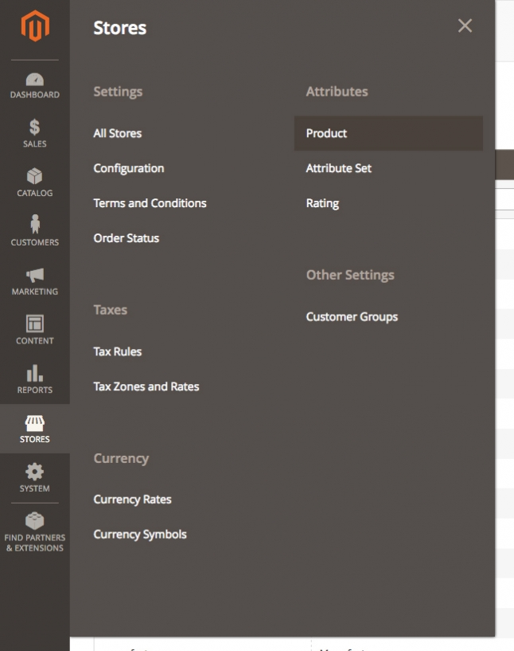

To create a new Attribute you should click on the **Add new attribute** button.

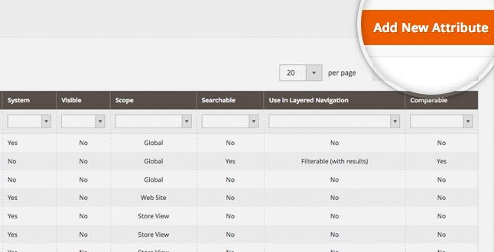

Once you are ready with the attribute, click on the **Save Attribute** button.

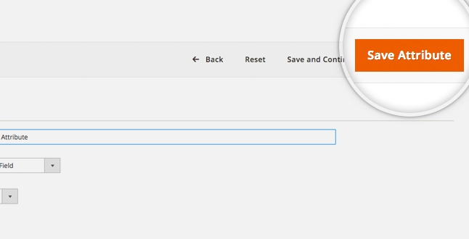

**2.4 Product Quality**

Magento provides you with an easy and yet powerful way to manage your product quantities. To do this, first login you Magento admin area and go to **Catalog -> Products**.

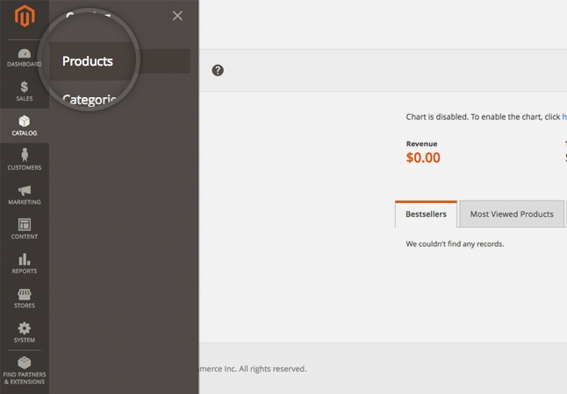

On this page, you will see a list of all of the products you've added to your Magento store. Locate the one you want to edit the quantity for and click on it to edit it.

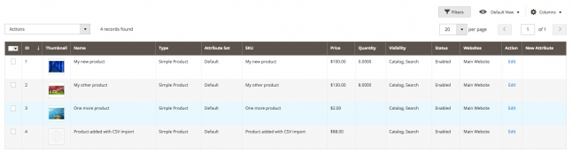

Doing so will take you to the page where you can edit every aspect of this product. Scroll down to the **Quantity** section and add the available amount of this product.

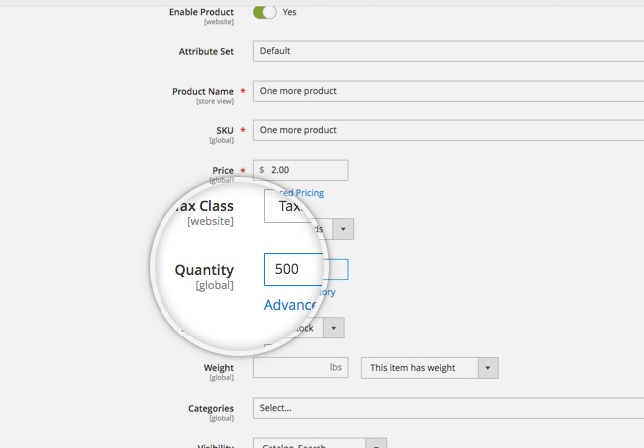

That's it, you can now track number of products of this type that you have in stock.

**2.5 Product price management**

Magento provides you with a lot of options for the prices of your products. You can configure special prices, timed promotions and much more. To start editing your product prices, first login to your Magento admin page and go to **Catalog -> Products**.

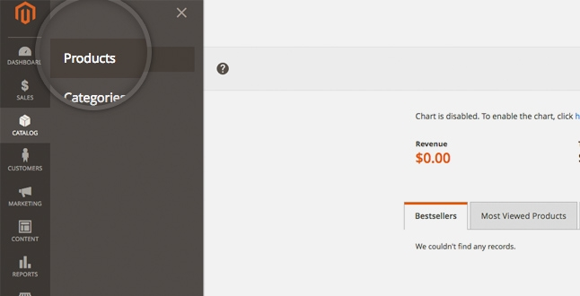

Now, locate the product whose price you want to modify and click on it to open up the Edit screen. Then next to the **Price** section you would see **Advanced pricing.**

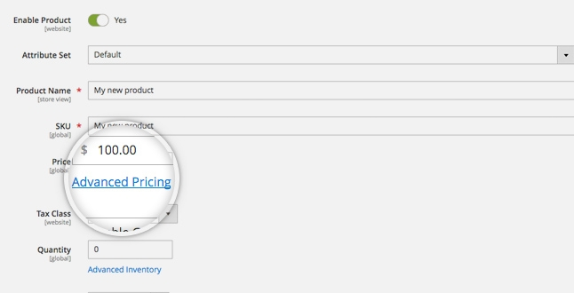

Click on the **Advanced pricing** link to open up a pop up window where you can set the pricing options.

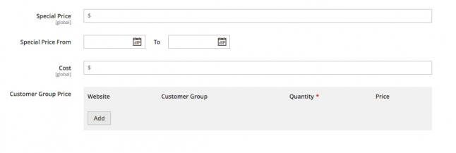

**Special Pricing** is a discounted price off of the retail price. It is most often used when an item is on sale. Special price can be set up with specific dates ranges so that you don't need to manually update each product when the sale is over. It can be configured via the **Special Price From** menu.

The **Cost** section is used to assign a cost price as well so you can manage profitability a lot easier.

To setup tier pricing, you should use the **Customer Group Price**. If you store has several websites, select the **Website** the tier pricing should be applied for. Select a **Customer Group** that the tier pricing should be applied for as well. In the **Quantity** field, enter the quantity that must be orders to receive the tier price and in the **Price** field, you should enter the price for specific amount of products.

* An **upsell** is to get the customer to spend more money – buy a more expensive model of the same type of product, or add features / warranties that relate to the product in question.
* A **cross-sell** is to get the customer to spend more money buy adding more products from other categories than the product being viewed or purchased.

**2.6 Import and Export Product list**

It is rather inconvenient to manually add a large number of products at once to a Magento installation. Inserting products one by one will take a long time especially when you have hundreds or thousands of products. In such cases you need an automatic way to add all those products to your Magento online store. We will address all steps you need to take in order to achieve a successful import.

First, access your Magento administrator backend and go to **Catalog -> Categories**.



Create all product categories you will need. You can do so by filling the form displayed below:



When you fill the form with all the information you like click the **Save Category** button.

Bear in mind that at this point you should make note of the newly created category IDs. It would be best to save them in a simple text file as you will need them for the import. The category ID will be displayed upon saving the category.

If you plan to have additional attributes for the products you are importing you will need to create those via **Stores** menu > **Product** under the **Attributes** section. You can use this functionality to add all custom attributes that are not present by default in a standard Magento installation. Note also that you can add additional attributes later at the moment you are creating a sample product. It is up to you whether to create the attributes before that or at the point you are creating the first product.

The next step is to manually add a product to your Magento installation. You will later export this product and use it as a template for importing the large batch. Make sure you include all attributes you will use for the products you are going to import in the sample product.

Once you create the new product and save it it will appear in the products list for your Magento store.



You are now ready to make the sample export that you will use as a template. In the Magento administrator area go to **System** menu **> Data transfer** section **> Export.** This would redirect you to a new page where you should select **Products** from **Entity Type** Dropdown and **CSV** from **Export File Format.**



Now you should exclude the unnecessary attributes from the list by selecting them and then click on **Continue** from the bottom of the page.This will save a new file on your computer with a name similar to catalog_product_YYYYMMDD_randomnumber.csv .The file will include columns for each of the attributes you have defined for your products. Open it in a spreadsheet program (MS Excel, Open Office Spreadsheet) and add the products you would like to import. Make sure you are copy/pasting the corresponding attributes in the correct columns. Also here is when you will have to add the category IDs. Use the IDs from the text file you saved earlier and put the corresponding category ID for the products you are adding.

Once you have accomplished the above go back to the Magento administrator area and go to **System** menu **> Data transfer** section **> Import.** Now select **Products** from the **Entity Type** dropdown. After that select **Products** from Entity Dropdown, and **Add/Update** from **Import Behaviour** dropdown. Now upload the CSV file by clicking on the **Browse** button next to **Select File to Import.**  If you have added images, you should also specify the path on the server where you uploaded them. Add the corresponding path to the **Images File Directory** section.

When ready click on the **Check data** button. If there are no issues or error with the import, a*File is vaild!* message and **Import** button would appear.



To initiate the process click on the **Import** button. When the import completes you will get the *Import successfully done* message.

